CREATING IBM CLOUD SERVICE

|  |  |
| --- | --- |
| Date | 03 November 2022 |
| Team ID | PNT2022TMID03606 |
| Project Name | Project – Real-Time River Water Quality  Monitoring and Control System |

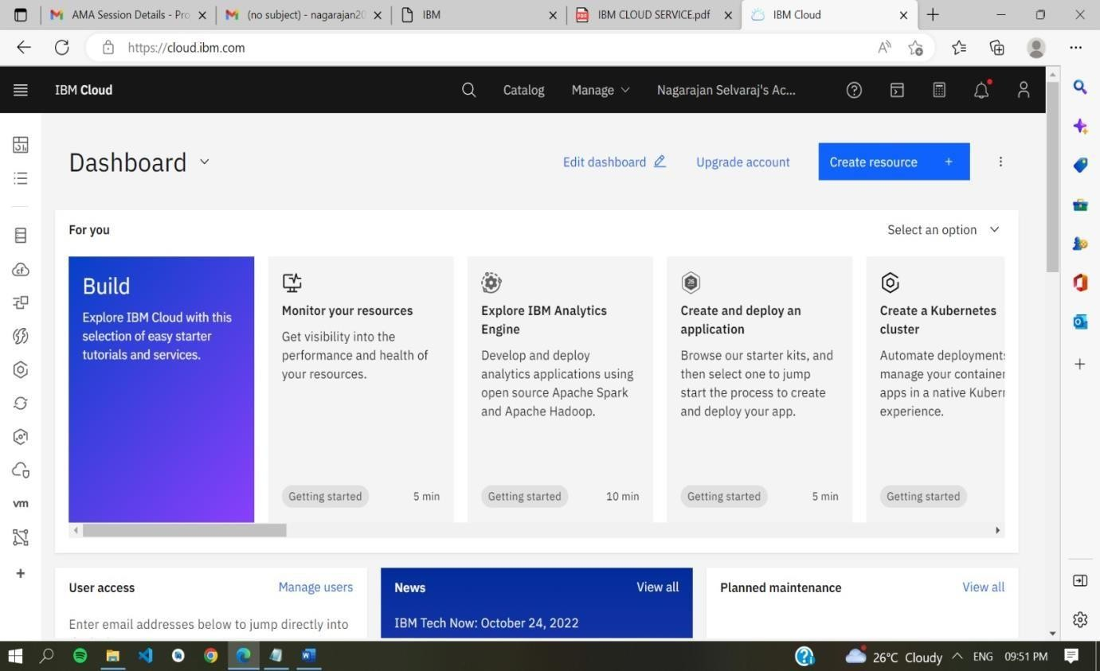

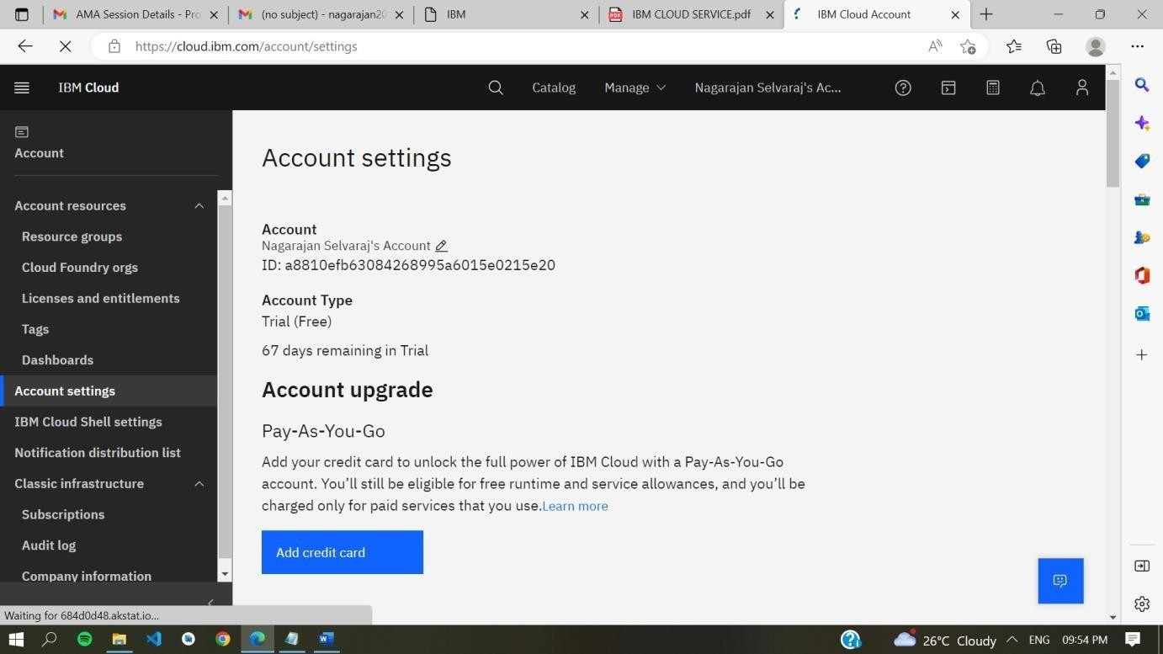

An IBM Cloud Service created Successfully .